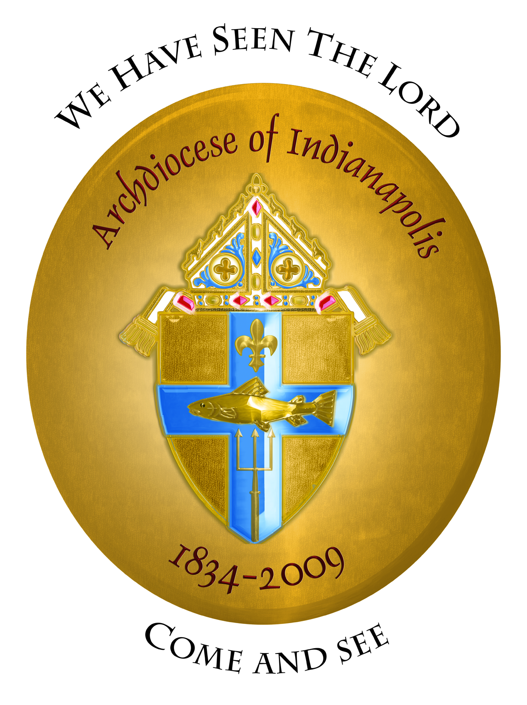

Saint Cecilia Sing and Mass with Archbishop Buechlein
Sunday, November 16, 2008, 2:30 P.M. (EST)
Saints Peter and Paul Cathedral

2:30 P.M. Saint Cecilia Sing

We will sing together and prepare the music for the Mass using a variety of styles and instruments and including the following selections:

“Come and See the Many Wonders” – 175th Anniversary Hymn– Harry Hagan OSB – SATB
“Halleluja! We Sing Your Praises” – Traditional South African, SATB
“Hymn to Saint Cecilia” – J. Robert Thompson, SATB
“Come to Us, Creative Spirit” – David Mowbray / Richard Proulx
“Take, O Take Me As I Am” – John Bell, SATB
“Bread of Life from Heaven / Pan de Vida Eterna – Susan Briehl / Marty Haugen

4:30 P.M. – Celebration of Mass and Blessing of Pastoral Musicians by Archbishop Daniel Buechlein

5:30 P.M. – Reception at the Catholic Center

All pastoral musicians and singers and others interested are welcome to participate in all three events or in the Mass and reception only.

In order to plan for the printed music and the reception, pre-registration is requested by contacting the Office of Worship by November 10, worship@archindy.org, 236-1479 or 800-382-9836, extension 1479.

